**Dashboard Design Hackathon for the Cricket World Cup**

**Follow us on Linkedin for more opportunities**

[**https://www.linkedin.com/company/innomatics-research-labs**](https://www.linkedin.com/company/innomatics-research-labs)



**Challenge starts** at 11:00 AM, 29th July, 2023 🕚

**Challenge ends** at 11:00 AM, 30th July, 2023 🕚

**What's in it for you?**

* Explore, Compete and Learn
* Get a chance to **get the PAID internship opportunity** with Innomatics Research Labs
* Best submissions(Top 5) will be invited to attend the paid internship from our Hyderabad office
* Pizza party 🍕 and goodies for lucky participants (Comment with an emoji on [**Linkedin Post**](https://www.linkedin.com/feed/update/urn:li:activity:7090922642890768384) to enter the lucky draw)

**What will you learn during this Hackathon?**

1. Video Tutorial to Deploy ReactJS App on Netlify - [**Click here**](https://youtu.be/bwhwVfWABYY)
2. React Documentation - [**Click here**](https://react.dev/)
3. Routing in React - [**Click here**](https://reactrouter.com/en/main)
4. How Fetch data from JSON - [**Click here**](https://stackoverflow.com/questions/50291822/fetch-data-from-json-file-in-react-js)

**Problem Statement**

To create an interactive and visually appealing dashboard that provides statistics, and insights for the ongoing Cricket World Cup. The dashboard should be built using React.js (or any other JS framework or library )

**Here are the key components and features you can include in your dashboard:**

## **Page 1: HOME PAGE**

The HOME page serves as the landing page for the Cricket World Cup dashboard. It should contain the following components:

* **Header**: Display the title of the dashboard and a navigation menu to switch between pages.
* **Countdown Timer**: Show a countdown timer displaying the time remaining to the next upcoming 2023 World Cup match.

## **Page 2: SCHEDULE PAGE**

The SCHEDULE page provides an overview of all the matches in the Cricket World Cup. It should include the following components:

* **Header**: Similar to the HOME page, include the title and navigation menu.
* **Filter Options**: Provide filters to allow users to sort matches by date, teams, or venues.
* **Match List**: Display a list of all the matches with brief information, such as teams playing, date, time, and venue..

You have to use JSON data to display all information related to Matches.

**Download the JSON Data for Dashboard creation -** [**CLICK HERE**](https://drive.google.com/file/d/1S70J4qLjvqgjRrXWBOJ7g-6rlQ8CawQm/view?usp=sharing)

**Refer below screenshot for reference**  
  
**Screenshot 1**  
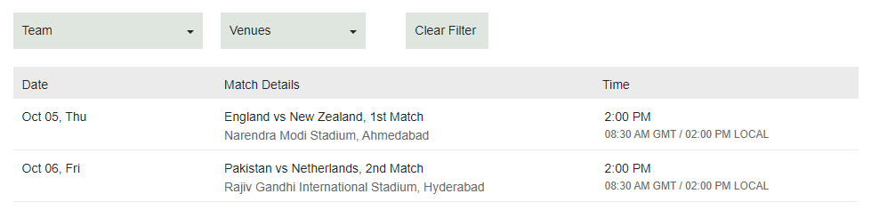

**Screenshot 2** 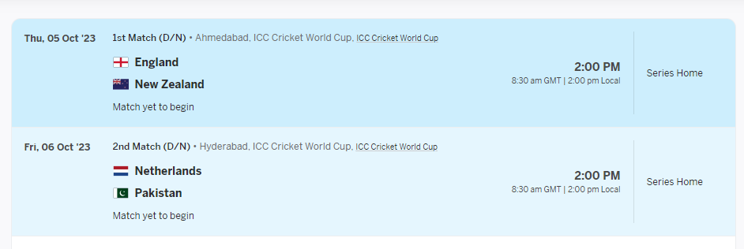

## **Page 3: Favorite Player Page (OPTIONAL TASK)**

Create a separate page where users can view detailed information about their favorite cricket player.

**Player Profile**: Show the player's profile picture, personal information, career stats, and recent performances.

**Add/Remove**:Provide an option to add/remove the player from the user's favorites list.

*(you can also use Redux concept here to implement Add/Remove )*

**Tools and Technologies:**

* React: Use React as the primary frontend library to build the dashboard.
* React Router: Implement React Router for navigation between different sections of the dashboard.
* Responsive Design: Ensure that the dashboard looks and functions well on different screen sizes, including mobile devices.

**Submission Guidelines:**

* Participants are required to create a GitHub repository for their project.
* Deploy the dashboard on a hosting service (e.g., Netlify, Vercel) to provide a live demo link.
* Test your dashboard thoroughly and ensure all components are working as expected.

Remember to focus on code quality, maintainability, and scalability while building the dashboard. Good luck, and let the cricket fever inspire your creativity! Happy hacking!

**Hackathon Submission**

* Write a Linkedin Post which reflects your work and experience for this hackathon. Don’t forget to tag Innomatics Research Labs in your posts.
* [**CLICK HERE**](https://forms.gle/GUYWzQmPP6d24J8g8) to submit your work.

**Note that:**

1. Any form of plagiarism will suspend your Hackathon submission, chance for any internship or other opportunities in future.
2. Comment with a funny emoji on our Linkedin post to win pizza parties 🍕 and goodies 🤭 during the assessment -[**Linkedin Post**](https://www.linkedin.com/feed/update/urn:li:activity:7090922642890768384)

**In case of any queries, comment on the** [**Linkedin Post**](https://www.linkedin.com/feed/update/urn:li:activity:7090922642890768384)

**All the Best!! 🎉**

**Explore our PLACEMENTS here:** [**Click Here**](https://www.innomatics.in/placements/)

**Refer a Friend and Earn:** [**Click Here**](https://www.innomatics.in/refer-a-friend/)